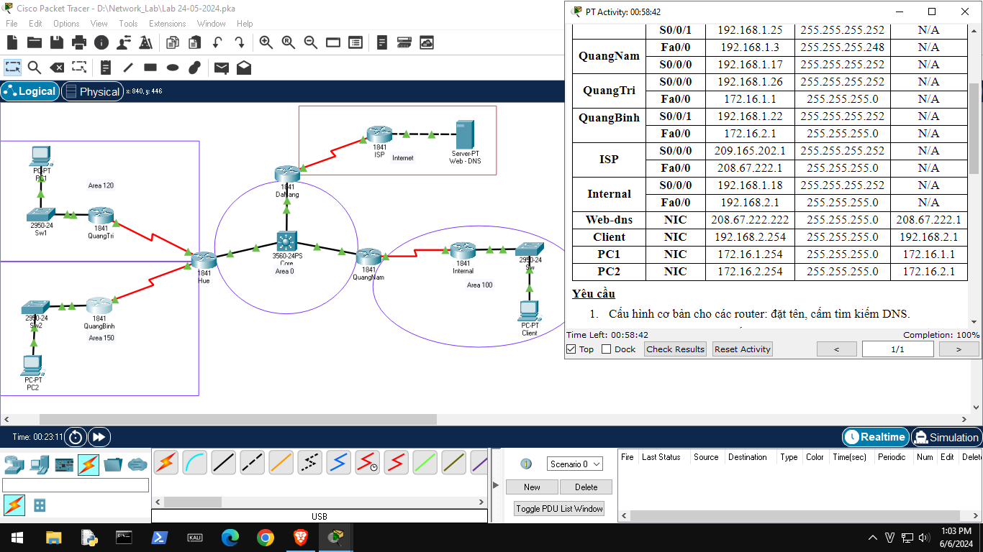

*Chú ý: Đảo 2 IP QuangTri S0/0/0 với QuangBinh S0/0/1 (Đề sai)

# Router DaNang

no ip domain lookup

interface fa0/0

ip add 192.168.1.1 255.255.255.248

ip ospf priority 150

interface s0/0/0

ip add 209.165.202.2 255.255.255.252

router ospf 100

network 192.168.1.0 0.0.0.6 area 0

default-information originate

ip route 0.0.0.0 0.0.0.0 209.165.202.1

# Router Hue

no ip domain lookup

interface fa0/0

ip add 192.168.1.2 255.255.255.248

interface s0/0/0

ip add 192.168.1.21 255.255.255.252

int s0/0/1

ip add 192.168.1.25 255.255.255.252

router ospf 100

area 120 stub no-summary

area 150 stub no-summary

network 192.168.1.0 0.0.0.7 area 0

network 192.168.1.20 0.0.0.3 area 120

network 192.168.1.24 0.0.0.3 area150

# Router QuangNam

no ip domain lookup

int fa0/0

ip add 192.168.1.3 255.255.255.248

ip ospf priority 100

int s0/0/0

ip add 192.168.1.17 255.255.255.252

router ospf 100

area 100 stub no-summary

network 192.168.1.16 0.0.0.3 area 100

network 192.168.1.0 0.0.0.7 area 0

# Router QuangBinh

no ip domain lookup

int fa0/0

ip add 172.16.2.1 255.255.255.0

int s0/0/1

ip add 192.168.1.26 255.255.255.252

router ospf 100

area 150 stub

passive-interface fa0/0

network 192.168.1.24 0.0.0.3 area 150

network 172.16.2.0 0.0.0.255 area 150

# Router QuangTri

no ip domain lookup

int fa0/0

ip add 172.16.1.1 255.255.255.0

int s0/0/0

ip add 192.168.1.22 255.255.255.252

router ospf 100

area 120 stub

passive-interface fa0/0

network 192.168.1.20 0.0.0.3 area 120

network 172.16.1.0 0.0.0.255 area 120

# Router ISP

no ip domain lookup

int fa0/0

ip add 208.67.222.1 255.255.255.0

int s0/0/0

ip add 209.165.202.1 255.255.255.252

ip route 0.0.0.0 0.0.0.0 209.165.202.2

# Router Internal

no ip domain lookup

int fa0/0

ip add 192.168.2.1 255.255.255.0

int s0/0/0

ip add 192.168.1.18 255.255.255.252

router ospf 100

area 100 stub

network 192.168.1.16 0.0.0.3 area 100

network 192.168.2.0 0.0.0.255 area 100